LADDER LOGIC

The Foundational Structure: From Physical Relays to Digital Logic

At its heart, **Ladder Logic** is the main language used to program **PLCs**—those industrial computers that keep machines running like clockwork.

But to really understand it, you’ve gotta know where it came from: the old days of **relay logic** and **hard‑wired control panels**.

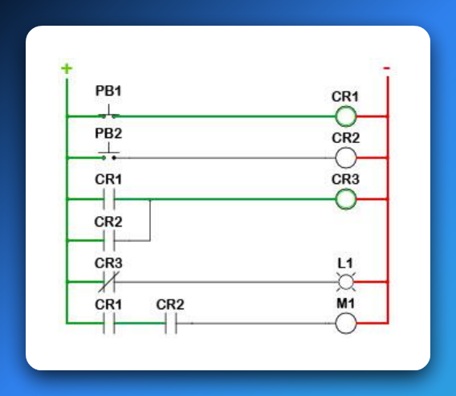

**⚡** 1. The Roots: Relay Logic & Hardware Automation

Before microprocessors were everywhere, factories used **physical relays** to automate machines.

A relay is basically an electrically operated switch:

✅ Send a small current through its coil → it creates a magnetic field → that pulls or releases a metal arm → opening or closing contacts to let power through.

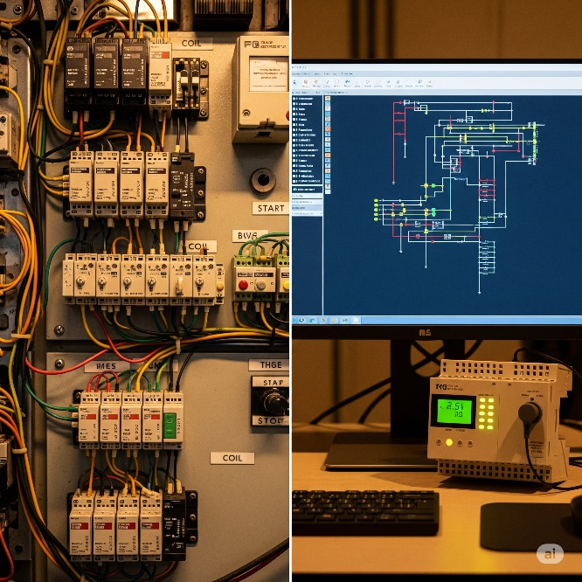

**💥** Why It’s Called a “Ladder”

It’s not just a cute name. Ladder Logic diagrams **look exactly like old relay wiring diagrams**:

Rails (Vertical Lines):

* The **left rail** is the power source (e.g., +24 V DC or 120 V AC).
* The **right rail** is the return path (common/ground).  
  Power always flows left to right.

Rungs (Horizontal Lines):

* Each rung is like one mini‑circuit or one logic rule.
* On each rung, you place components—switches, contacts, coils—in **series** or **parallel**.
* If the path on that rung is complete, the output on the far right energizes.

**⚙️** How It Worked (and Still Does in Principle)

In an old relay cabinet:

* Power starts at the **left rail**, passes through inputs like pushbuttons or sensors, then through relay contacts, and finally reaches an output device like a motor, light, or another relay coil.
* **If every condition on that rung is true (closed contacts, active sensors)** → the circuit completes → the output device gets power and turns on.

Modern Ladder Logic in a PLC mimics this exact same idea—*but instead of physical wires and relays, it’s all done in software.*

**✨** 2. The Evolution: From Tangled Wires to Clean Software Bits

The genius of **Ladder Logic** is how it took the messy world of physical relays and turned it into a neat software language.

Instead of grabbing a screwdriver and wiring real relays together, you **“draw” your logic on-screen** with symbols that look just like the old electrical components.

When the PLC runs your program, it’s basically *pretending* electricity is flowing through those virtual circuits.

**🖥️** Digital Translation – How It Maps Over

Power Flow:  
In software, there’s no real current. Instead, a logical **TRUE (1)** means “power is flowing” along that rung. If the path from the left rail to an output is logically true, that output gets activated.

Open vs. Closed Contacts:  
Physical relay contacts become simple Boolean conditions in the PLC:

* **Normally Open (NO)** – shown as —| |—  
  ✅ True when the input is ON (button pressed, sensor triggered, relay energized).
* **Normally Closed (NC)** – shown as —|/|—  
  ✅ True when the input is OFF (button released, sensor not detecting, relay not energized).

Coils / Outputs:  
Outputs are shown as —( )—.

🚨 When the rung logic leading to that coil is TRUE, the PLC sets that output bit to **1**, which energizes the real-world device (motor spins, light turns on, valve opens) or even an internal memory relay.

👉 Big Picture:  
Instead of digging through wires in a control cabinet, you’re now dragging and dropping logic in software.

**Same principles, zero mess.** That’s the magic of Ladder Logic.

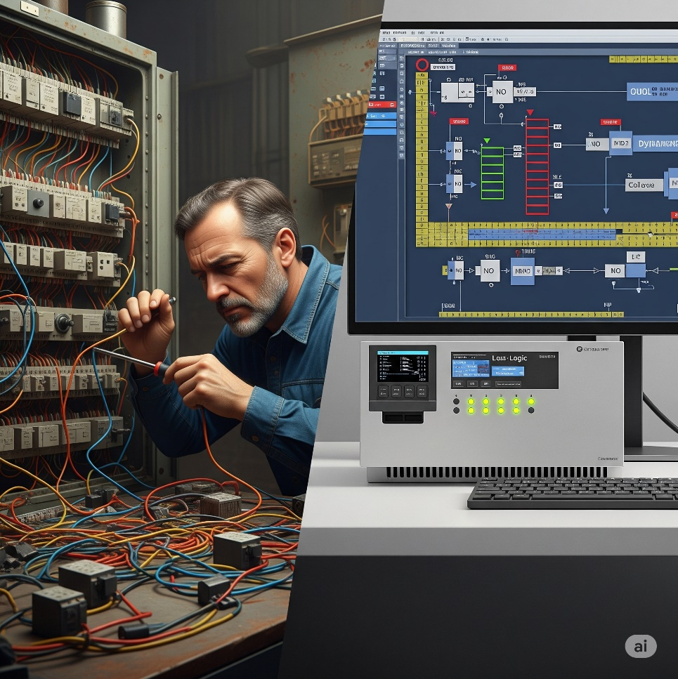

**🏗️** Key Ladder Logic Components & Their Analogies

Let’s break down those classic symbols from your image and see how they vibe both in hardware *and* in software logic:

**🔘** PB (Pushbutton) – Your Event Trigger

**PB1, PB2:** These are **inputs**.  
On a real panel, pressing a pushbutton closes a circuit and sends a signal into a PLC input terminal.  
In Ladder Logic, it’s represented by a contact symbol.

**👉 Analogy:**  
A pushbutton is like calling a function or triggering an interrupt in code.  
When you hit it, you’re saying: *“Yo, start that sequence!”*

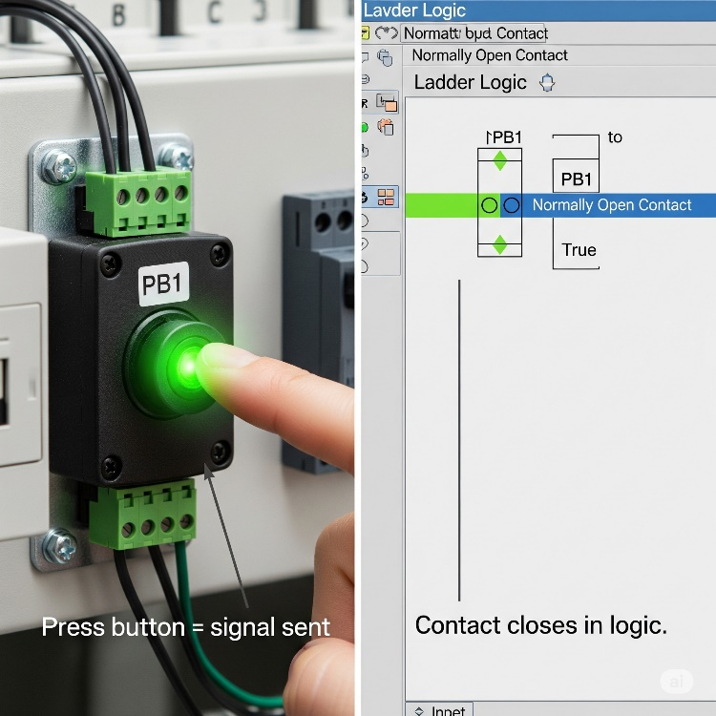

**⚡** CR (Control Relay) – Your Internal State & Your Electrical Middle‑Man

**CR1, CR2, CR3:**  
Inside Ladder Logic, we treat these as **internal memory bits** — energize the coil (CR1) and every CR1 contact in your logic instantly follows that state.

**But in the real hardware world?**  
A control relay also acts as an **electrically controlled switch**.  
It lets the PLC — which only pushes tiny, low‑power signals — safely control **higher‑power devices** like motors, solenoids, or large lamps.  
It’s the buffer between the fragile logic electronics and the beefy machinery, giving you:  
✅ **Electrical isolation** (protects your PLC from power spikes),  
✅ **Safety** (no direct heavy current through your delicate PLC board),  
✅ **Stability** (reliable switching for big loads).

**👉 Analogy:**  
Think of it as a bouncer at a club.  
Your PLC quietly whispers, “let them in,” and the control relay (the bouncer) swings open the big heavy door to the motor or solenoid.  
The PLC never has to wrestle with high current directly — the relay does the heavy lifting.

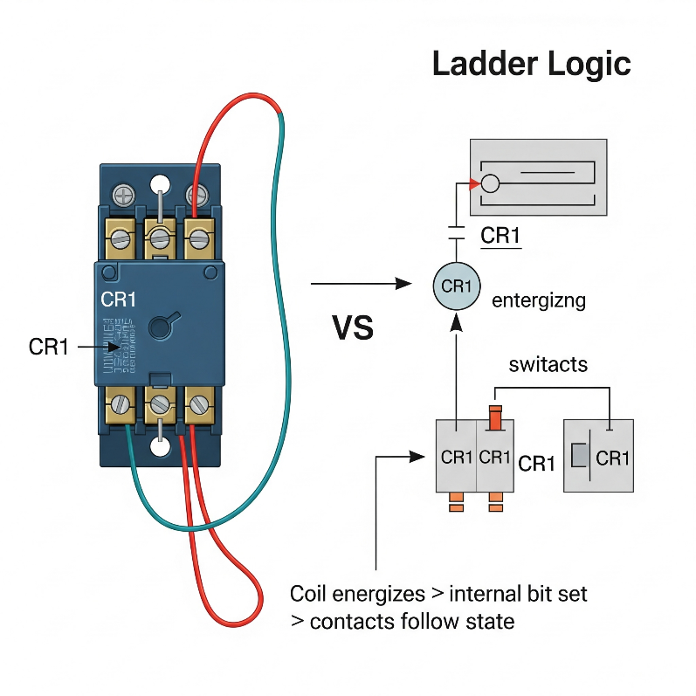

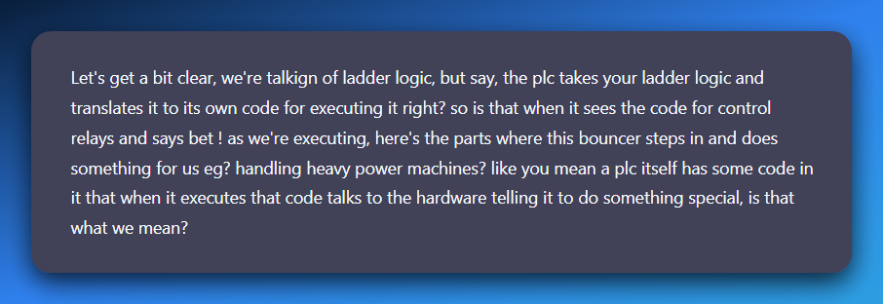

Inside your ladder, when you drop in a coil (CR1) or an output (M1) you’re basically saying to the PLC:

*“Hey PLC, if the logic on this rung is true, energize this output (or set this internal bit).”*

**What happens next depends on what type of coil it is:**

**💥** Internal CR (Control Relay):

* This one lives purely in PLC memory.
* When the CPU executes that rung and it’s true, it sets a *bit* in memory to 1.
* Any rung reading that contact (—| |— CR1) will now see it as “closed.”  
  👉 No actual electricity is switching heavy loads yet — it’s just logic inside the PLC.

**💥** Physical Output Coil (like M1 for a motor):

* When the CPU executes that rung and it’s true, it flips a transistor or energizes a tiny driver circuit on the PLC’s output card.
* That tiny driver is *not* strong enough to power a motor directly — and that’s where real **control relays** or **contactors** out in the panel come in.
* The PLC output energizes the relay coil (low current).
* The relay’s contacts then safely switch the **big current** going to your motor or solenoid.

The PLC scan loop runs through your compiled logic thousands of times a second. Each time it hits an output coil instruction, the CPU updates the hardware output register.

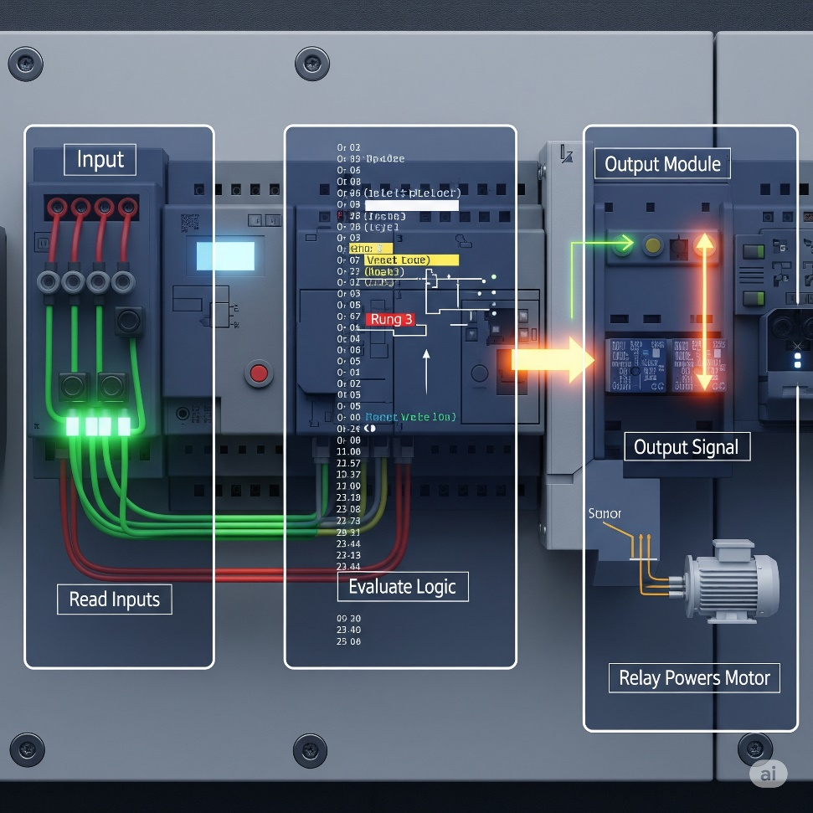

**That register is connected to output modules** — which physically drive relay coils, solid‑state switches, or transistors on your control panel.

The **PLC isn’t** literally muscling 10 amps into a motor — it’s *flipping a small digital signal* that *commands* the relay/contactors to handle the big current.

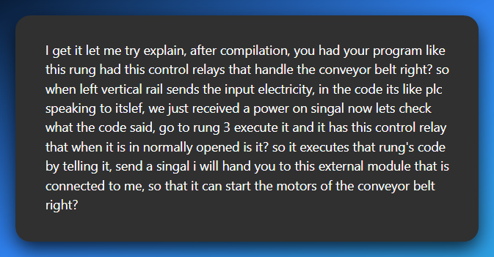

After your ladder logic is compiled, the PLC is constantly scanning. Imagine we’re mid‑scan:

⚡ Input side:  
The PLC reads the status of all input terminals (pushbuttons, sensors, etc.).  
👉 The left rail is like “power” coming in, but in PLC land it’s really just reading TRUE/FALSE from each input.

🧠 Logic side:  
Now the PLC runs through your ladder rungs, top to bottom: *“Ok, rung 3… oh, this rung has a coil that controls the conveyor motor. Let’s check the contacts in this rung.”*

It evaluates your contacts (normally open/closed) based on the input states and internal bits. If the logic path is TRUE (like that normally open contact is now closed because the button was pressed): *“Alright, condition is true — energize that output coil!”*

📤 Output side:  
The PLC doesn’t directly blast **3-phase power(typically provides higher electrical power)**. Instead, it sends a low‑power signal out of an output pin on the output module:

*“Hey output module, set your transistor/relay ON for Conveyor_Motor.”*

🔌 External world:  
The output module energizes a control relay or contactor coil out in the panel.  
**That relay/contact closes heavy-duty contacts that feed the actual conveyor motor’s power circuit.** 👉 And boom — your conveyor motor spins up. 🚀

**🤖** So your sentence becomes:

*“When the PLC is scanning and gets to rung 3, it evaluates that rung’s logic (including your control relay contact). If the logic is TRUE, the PLC sends a signal from its output module to energize an external relay or contactor, which then powers the conveyor motor.”*

Your idea is absolutely right.  
✅ Left rail = inputs read.  
✅ Code rung-by-rung.  
✅ If logic says “go,” PLC outputs a low‑power signal.  
✅ Output module reads the signal → control relay/contact closes → heavy machine (like the conveyor starts moving).

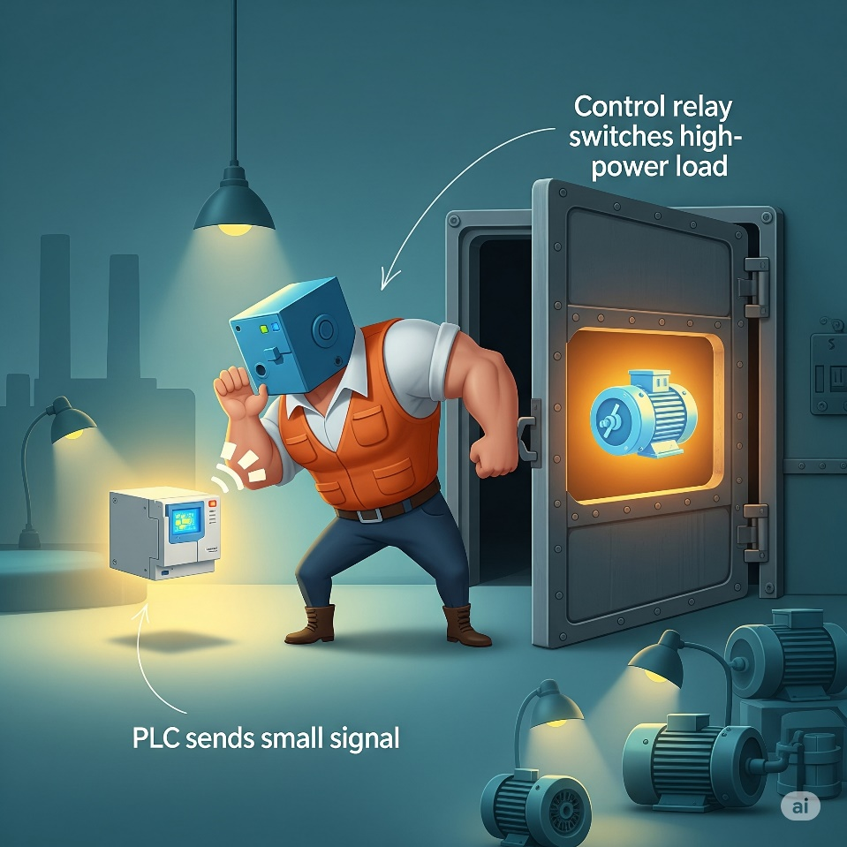

We talked about **(CR1)** as a "coil" and (L1) or (M1) as "output devices." These are essentially the "coils" that get energized.

When a rung's conditions are met, the "output coil" on that rung gets "energized." If it's an internal CR (Control Relay), it sets a memory bit.

If it's a physical output like L1 or M1, it triggers the corresponding output module on the PLC to provide power to the actual device.

**⚡** The Evolution from Wires to Code – Ladder Logic’s Secret Sauce

*Ladder Logic* didn’t just give old relay panels a digital facelift — it *fundamentally changed* how we think about control systems.

Back in the day, every single relay, switch, and motor in a factory had to be hard‑wired together.

If you wanted to change how it behaved, you grabbed a screwdriver and rewired the whole panel (and probably swore a lot).

Now? Those same circuits *live as memory bits* inside a PLC. Instead of cutting and crimping wires, you “draw” your circuit in software — and the PLC turns that into real‑world action.

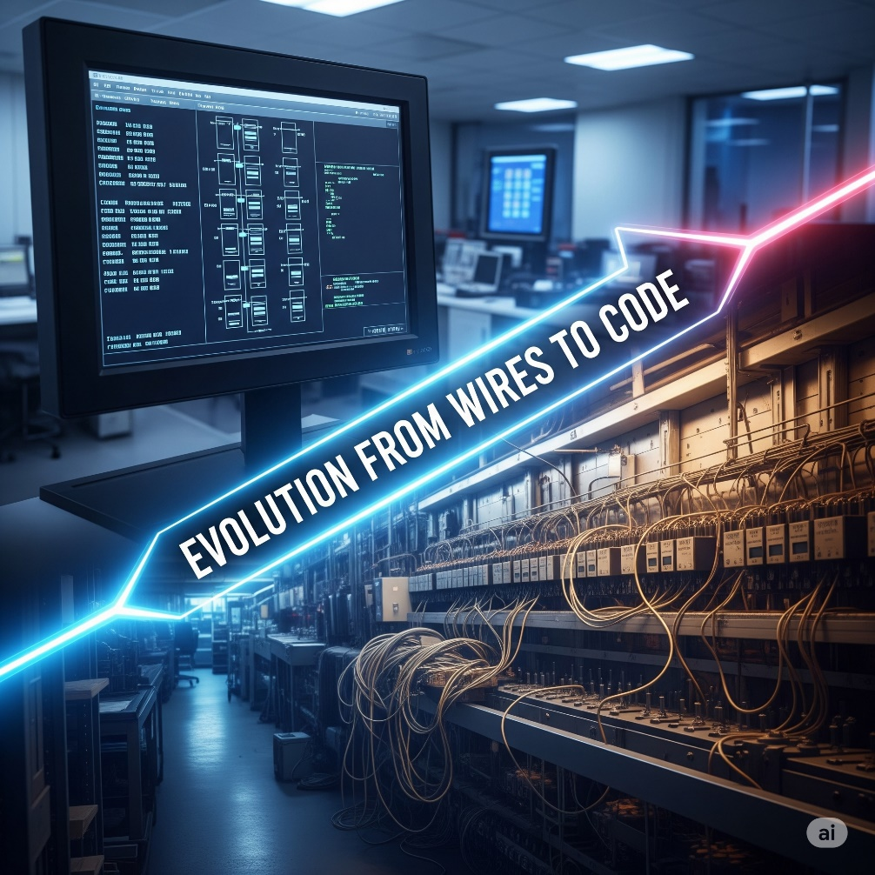

**🛠️** The Ins and Outs: Where Hardware Meets Software

A PLC lives in two worlds at once:

* **Physical world:** pushbuttons, sensors, motors, lights.
* **Digital world:** memory tables, logical rungs, and CPU scans.

The bridge between them? **Input/Output (I/O) modules.**

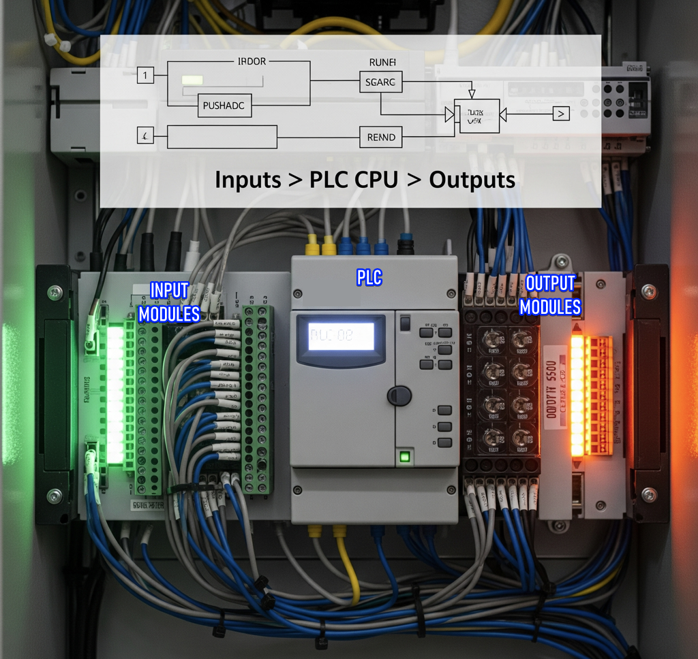

**👁️** Inputs: The PLC’s Eyes and Ears

Inputs are like sensors feeding data into your system.

They are physical devices — like **pushbuttons (PB)**, **limit switches**, **sensors**, etc. These devices connect to the **PLC's input module**, which monitors whether there’s voltage at each terminal.

When voltage is detected, the PLC sets an internal **memory bit** for that input to TRUE (or 1). That bit can then be referenced in your ladder program.

*Ladder logic was designed to have the same look and feel as ladder diagrams, but with ladder logic the physical contacts and coils are replaced with memory bits.*

**🧠** Example: PB1 and X001

In the diagram, you see:

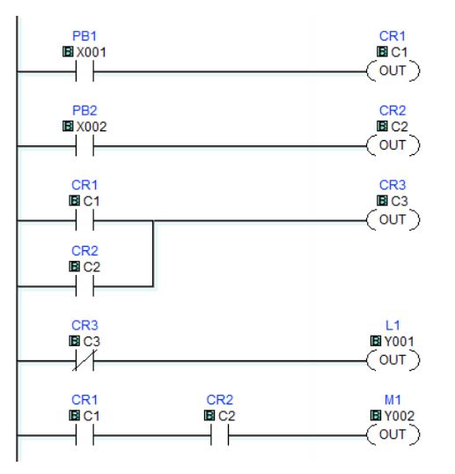

* PB1 is a **physical pushbutton** connected to input terminal **X001**.
* When you press PB1, voltage is sent to that terminal → PLC sets **X001 = TRUE**.
* In the ladder diagram, the —| |— symbol means "check if this bit is TRUE".
* If X001 is 1, the virtual contact **“closes”** and logic can flow to the right.

💡 **This is what we mean by "normally open"**:

The contact —| |— is **open** (no logic flow) unless the bit it watches becomes TRUE.

**🔴** Outputs: The PLC’s Muscles

Outputs are how the PLC **acts on the world** — turning on lights, motors, alarms, etc.

When your ladder logic energizes an **output coil**, the PLC sets the corresponding **Y-bit** in memory. That tells the **output module** to physically energize the circuit.

**⚡ Example: L1 and Y001**

On this rung:

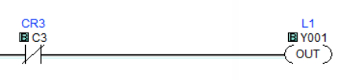

* CR3 (internal bit C3) must be TRUE.
* If so, the output coil Y001 is energized.
* That flips the bit in the output module → current flows → **L1 (a light) turns on**.

**🧠 Analogy:**

* Inputs = "Status updates" from the real world.
* Outputs = "Commands" sent out to the real world.
* The CPU = The brain that interprets inputs and triggers outputs via logic.

**🌀** Internal Bits (Like CR1, CR2, CR3)

Not all contacts and coils represent **real-world hardware**.

CR1, CR2, CR3 are **internal control relays**:

* They're like virtual relays inside the CPU.
* They're used for logic control only — not connected to physical I/O.

For example:

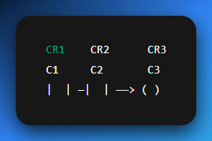

This rung says:

*“If internal relay C1 is TRUE and C2 is TRUE, then set C3 = TRUE.”*

This kind of logic lets you build **intermediate steps**, sequences, and memory-like behavior.

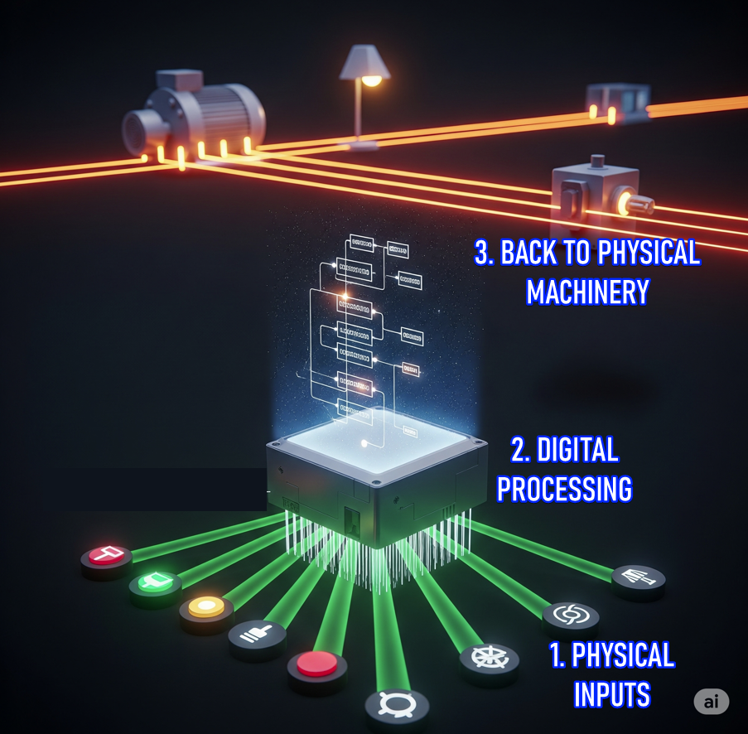

**⚡** TLDR: Why Ladder Logic Hits Different Now

Ladder Logic transformed factory control from **hardware headaches** to **software smoothness**.  
Back then? Changing behavior meant rewiring physical panels — hours of work, high chance of mistakes.  
Now? It’s just: **edit → download → done**.

Behind the scenes, those chunky relays and switches are now just **memory bits** in the PLC's brain (X, Y, M, etc.).

🤔 So, what’s really happening?

* 🧠 **Inputs** → Digital bits (from input modules)
* **🖥 Logic** → Runs through virtual rungs in PLC memory
* ⚙️ **Outputs** → Real-world actions (through output modules)

When your ladder rung hits true, it’s like the PLC says:

*“Yo, flip this bit. Let’s run that motor.”*

And the output module?

“Say less. Power’s going live.”

**🔄** Tying It All Together — One Rung at a Time

Let’s walk through how **electricity "flows"** in this PLC program using your image:

1. **Rung 1:** PB1 (X001) must be pressed → sets CR1 (C1) = TRUE
2. **Rung 2:** PB2 (X002) must be pressed → sets CR2 (C2) = TRUE
3. **Rung 3:** CR1 and CR2 must both be TRUE → sets CR3 (C3) = TRUE
4. **Rung 4:** If CR3 is TRUE → turn on L1 (connected to Y001)
5. **Rung 5:** If both CR1 and CR2 are TRUE → turn on M1 (connected to Y002, possibly a motor)

**⚠️** Quick Note on Contacts

* **—| |—** → **Normally Open Contact** (logic flows when bit is TRUE)
* **—|/|—** → **Normally Closed Contact** (logic flows when bit is FALSE)

This diagram uses all **normally open** contacts, which means:

*“Let power through only when the bit is active.”*

**🧠** Memory View

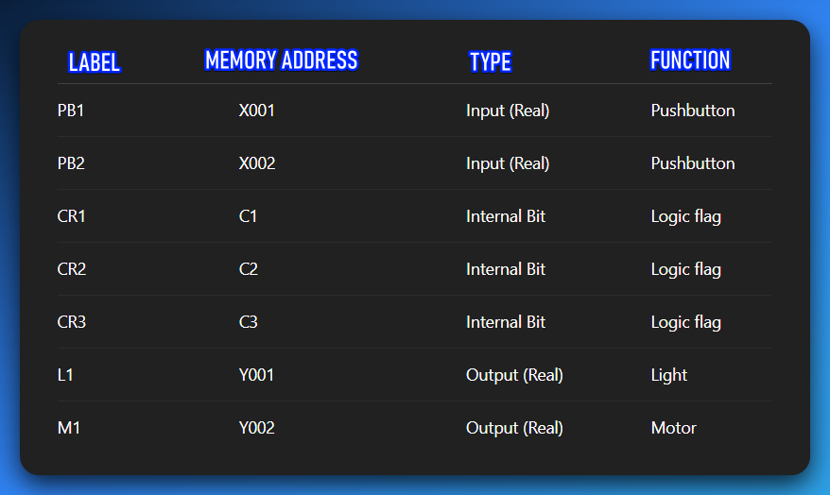

**🧩** Final Summary

*“Press PB1 and PB2 → set internal logic relays → light and motor activate. All through virtual contacts, no physical rewiring needed. Just bits flipping in the PLC's mind.”*

Now that’s how you do modern industrial control — with **digital muscle, logic memory, and clean ladder flow.**

**🧠** Internal Bits = Pure Logic Power

Not everything in your ladder program needs to control a real-world device. Some bits exist just to help you **structure logic cleanly and smartly**.

Control Relays like CR1, CR2, CR3 are **internal memory bits** — like **flags** or **global variables**.

* One rung might **set CR1 = TRUE** (e.g., after certain conditions are met).
* Other rungs can then **check CR1** as if it were a real input — no wire needed.

**💡 Think of it like:**

* CR1 is your custom signal — a pure memory trigger.
* It's like bool CR1 = true; in C.
* Or a malware flag: isPayloadReady = true.

These bits **don’t control power** directly — they **control logic**, and logic controls everything else.

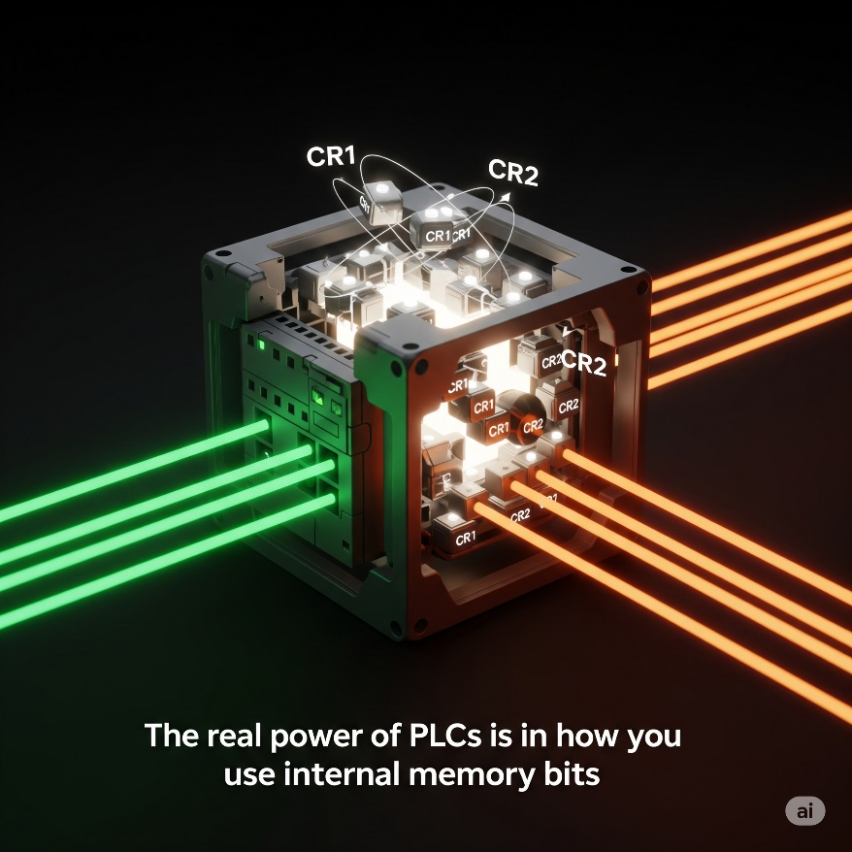

*“The real power of PLCs isn’t just physical I/O — it’s how smartly you use the memory bits between them.”*

✅ Yes, the sequence is:

1. **An input energizes the PLC** (button pressed / sensor triggered).
2. **PLC logic decides → sends out a low‑power signal** from its output module.
3. **That low‑power signal drives a control relay coil** (CR).
4. **The relay’s heavy contacts switch on** and supply high power to a machine (motor, lamp, conveyor).

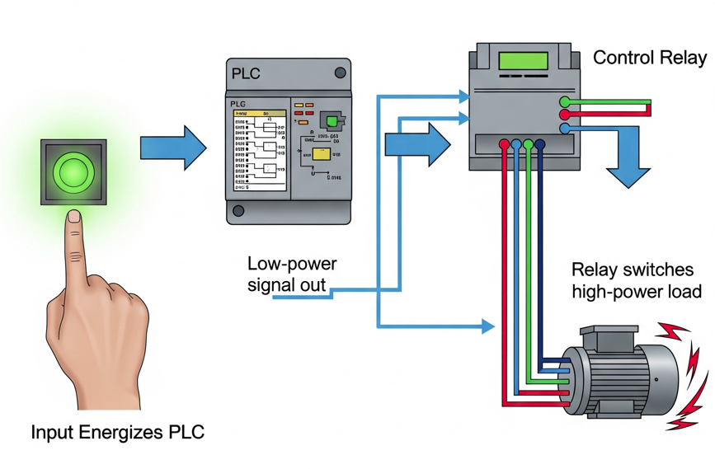

**✨** Temporary Storage and Modular Thinking

**Internal bits** aren’t just for keeping states.  
They’re also great for **holding intermediate results.**Instead of cramming everything into one messy rung, **split the logic into smaller rungs.** **Store** each step’s result in an internal bit.  
It makes your program cleaner, easier to read, and way easier to debug later.

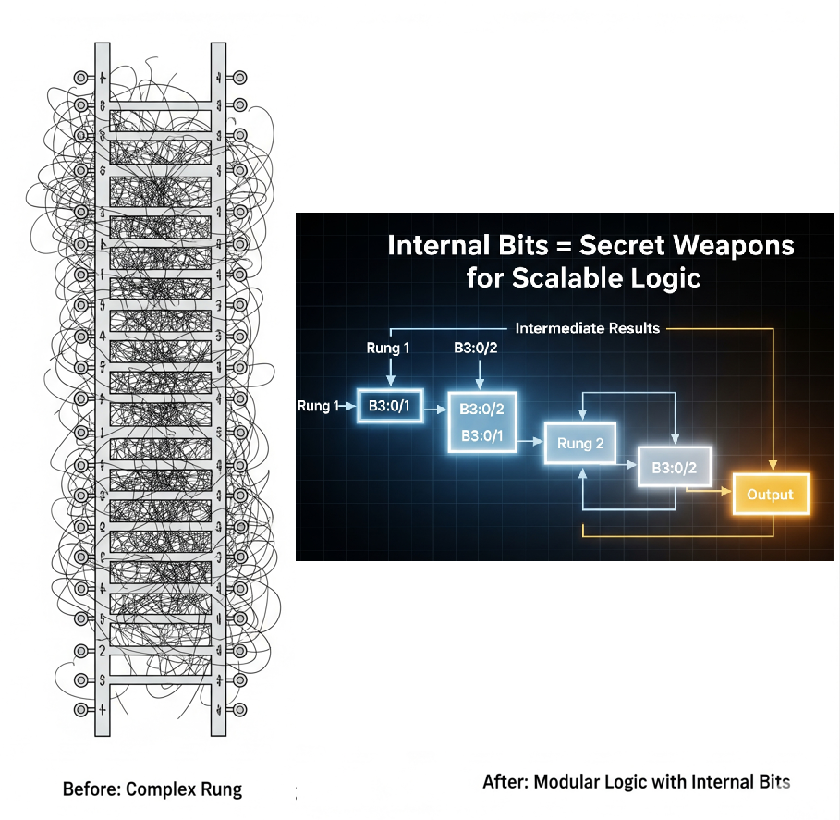

**💡** Bottom line:  
Internal bits are your secret weapons. They let you build smarter, layered logic without adding extra hardware. Combine them with your PLC’s advanced features, and your ladder program becomes a powerful, professional‑grade control system.

Beyond Basic Contacts and Coils: The Modern PLC's Capabilities

While your provided text wisely advises keeping it simple for an introduction, it's vital to acknowledge that **today's PLC CPUs offer a vast array of sophisticated functions, far beyond mere contacts and coils.** This is where the PLC truly transcends its relay logic ancestors and becomes a powerful industrial computer:

* **Math Functions:** Addition, subtraction, multiplication, division, and more complex arithmetic operations. Essential for controlling variables like temperature, pressure, flow rates, and calculating production metrics.
* **Shift Registers:** Used for tracking items as they move along an assembly line, often used in conjunction with sensors to monitor position and sequence.
* **Drum Sequencers:** Imagine a virtual "drum" with multiple tracks, each controlling a specific output or action based on a sequence of steps. Ideal for automating repetitive, multi-step processes like batch mixing or complex assembly operations.
* **PID Control:** Proportional-Integral-Derivative controllers are advanced algorithms used for closed-loop feedback systems (e.g., maintaining a constant temperature in an oven by adjusting heater power based on temperature readings).
* **Data Handling:** Instructions for moving, comparing, and manipulating blocks of data.
* **Communication Protocols:** Built-in support for industrial networks (Ethernet/IP, Modbus TCP, Profinet, etc.) to communicate with other PLCs, HMIs (Human-Machine Interfaces), SCADA systems, and even enterprise databases.
* **Structured Text, Function Block Diagram, SFC:** Modern PLCs often support other IEC 61131-3 programming languages, allowing for more complex, high-level programming constructs similar to C or Pascal.